**Educational Organisation Using Servicenow Team ID : NM2025TMID00243**

**Team Size : 3**

**Team Leader : .Mercy j**

**Team member :Antony Lishma s**

**Team member :Prajeeba B**

**Objective:**

To design and implement a ServiceNow solution that enhances the student experience by providing a unified platform for service requests, issue tracking, and academic support — improving communication and response efficiency across departments.

**Skills:**

ServiceNow portal customization

Flow Designer & Virtual Agent configuration

Knowledge Management & Case Management

JavaScript scripting and UI policies

Integration with Learning Management Systems (LMS)

**TASK INITIATION**

**Milestone 1 :User**

**Activity 1: Create an Users Creating a Update Set**

1. Click on All >> Local update sets .

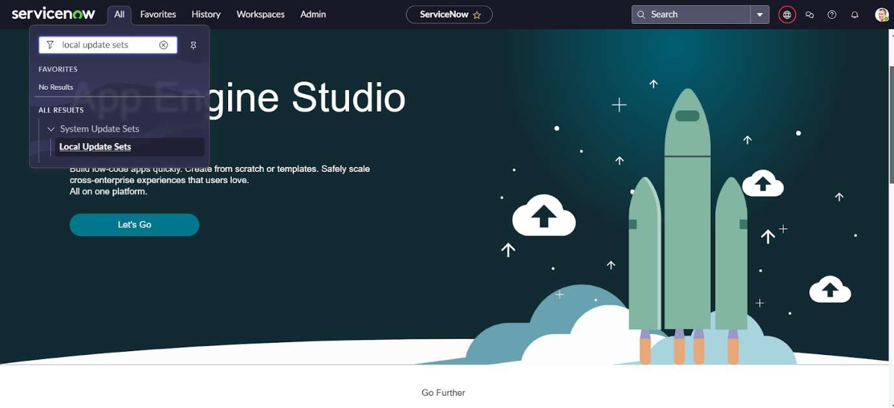

1. Click on new

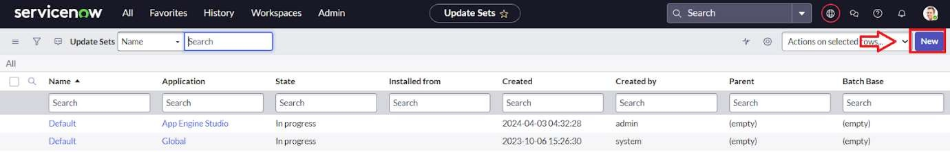

1. Enter the Details Name: Educational Organisation >> Click on Submit and make Current.

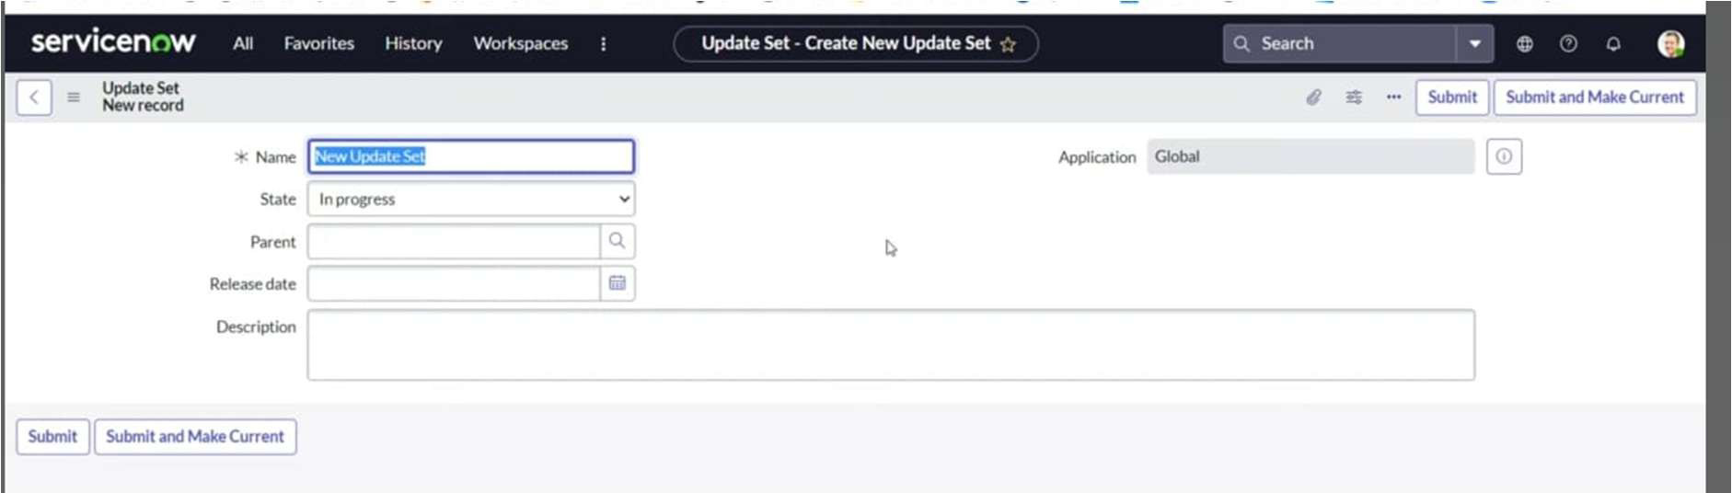

# Creating Salesforce Table.

* + All >> Tables.

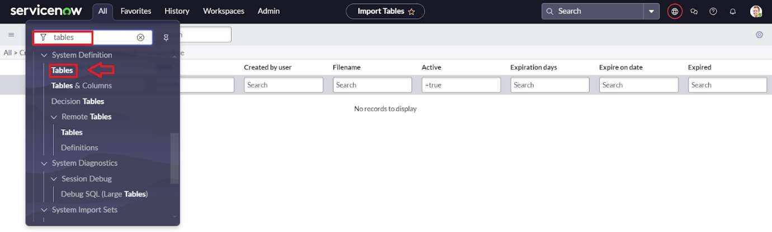

* + Click on new

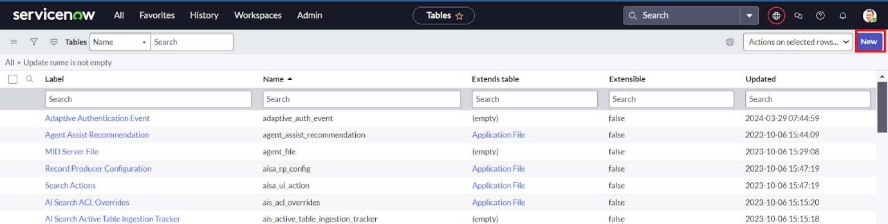

* + Enter the Label(Anything you want): Salesforce >> Click on Name it will Automatically generate Api name.

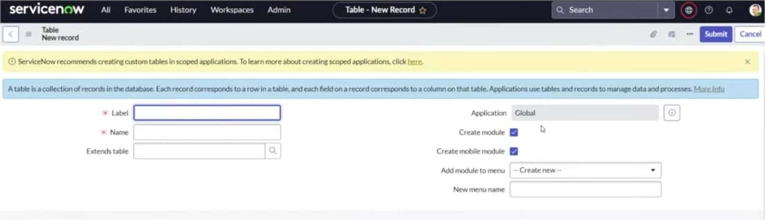

* + Create columns as given below, Double Click on Column label and Enter the Column labels and click on the tick mark >> Give Type as given .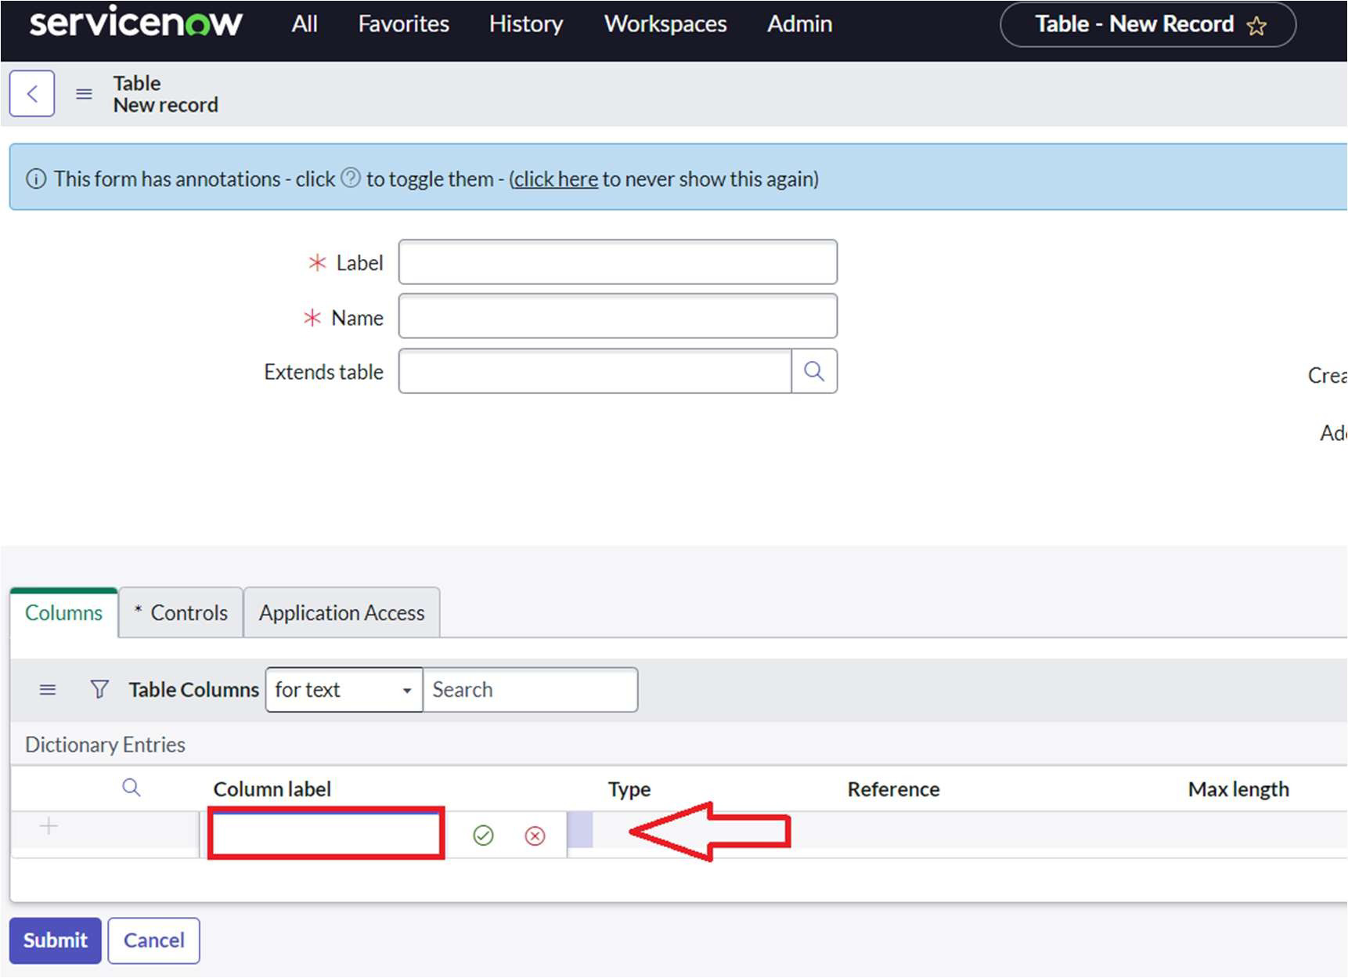

# x

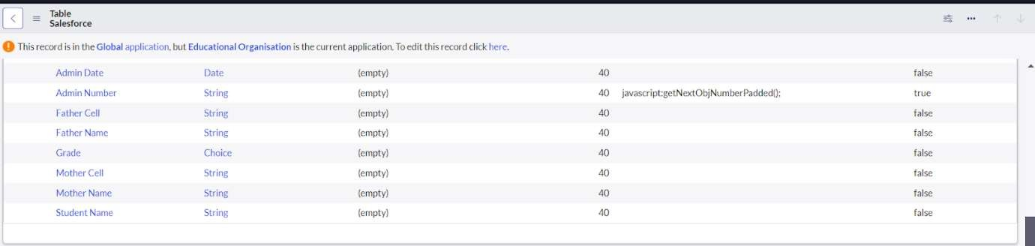

* + For “Admin Number” Give Display as True and right click on the toggle bar on top >> save.

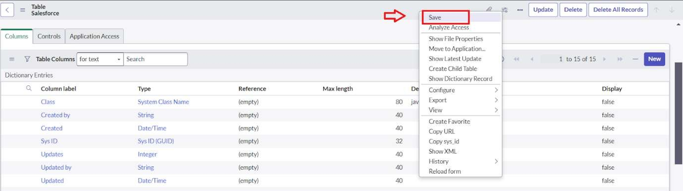

* + Click on controls >> Enable Extensible.
  + 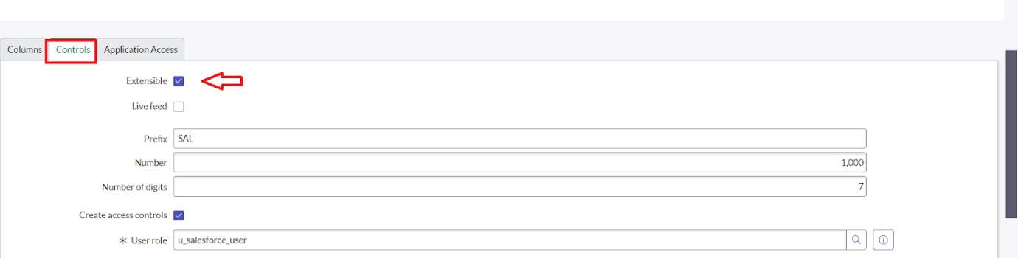
  + Click on “Admin Number” column, In Related Links Click on Advanced View >> Default View (Enable Use dynamic default) >> select Get Next Padded Number in Dynamic default value >> Update .

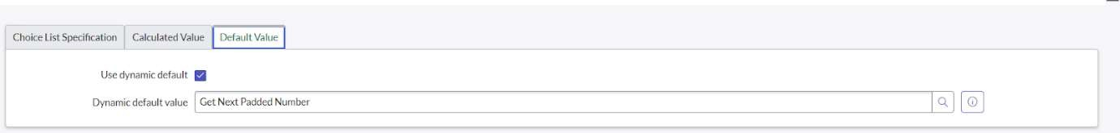

* + Click on “Grade” Column >> Click on Choices and give Label, Value and Sequence as given below.

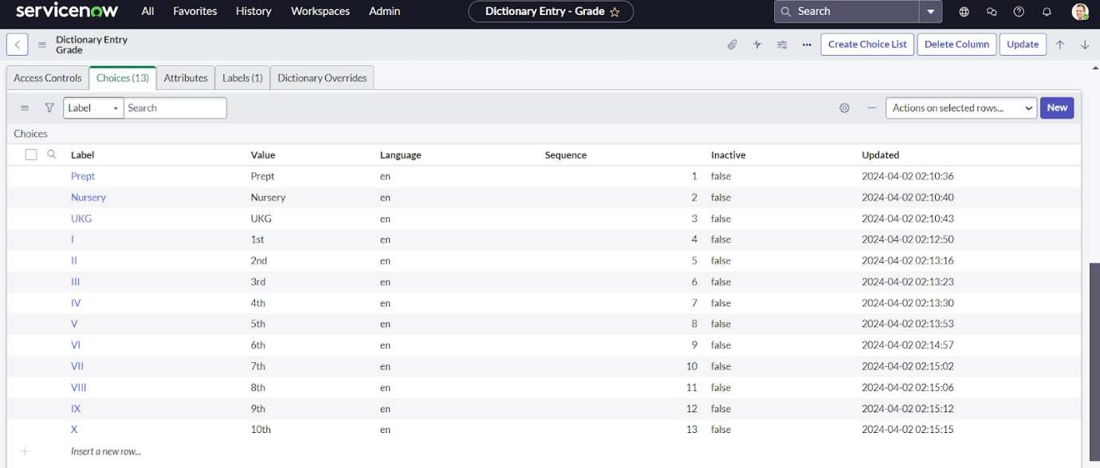

# Creating Admission Table

* + Create an Admission Table with Columns given.
  + Select Extends Table >> Salesforce and also Select Add module to menu >> Salesforce.
  + Create Fields as shown

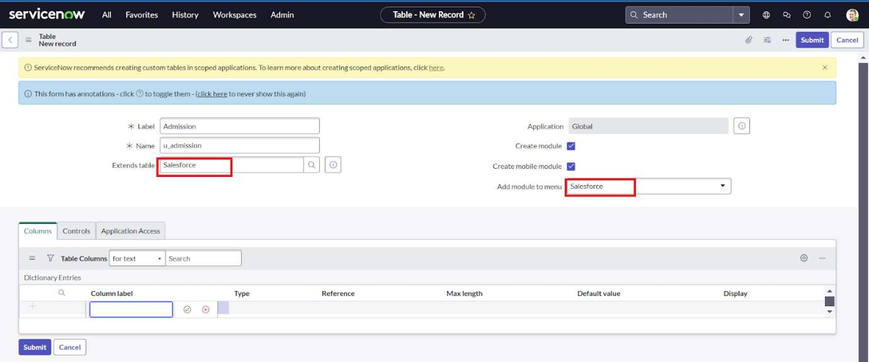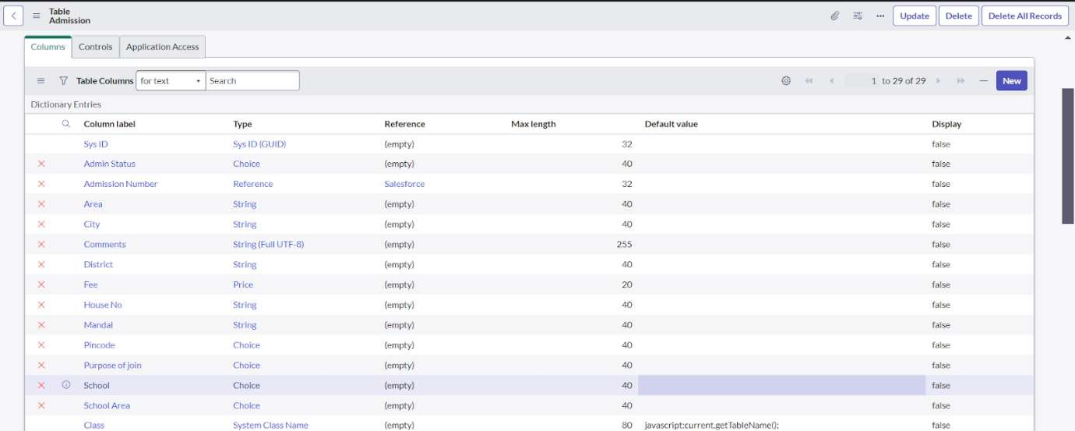

* + Create choice for Admin Status as:

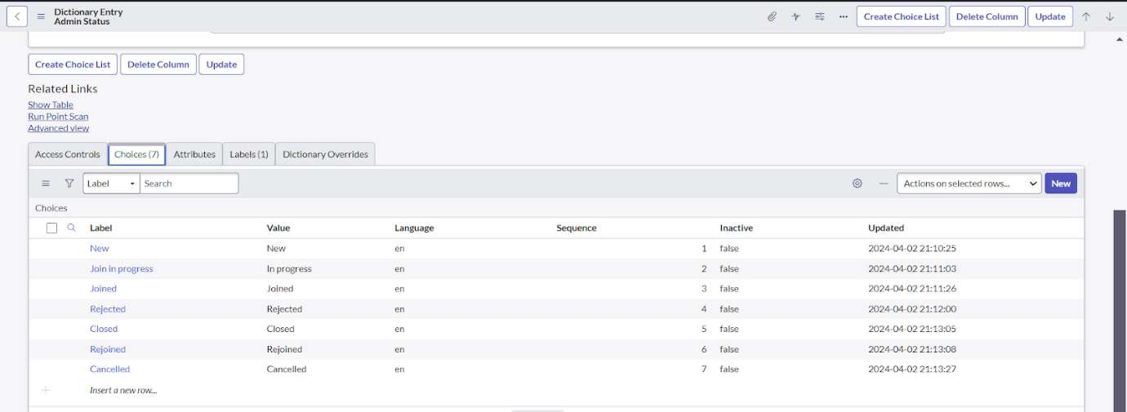

* + Create choice for Pincode as:

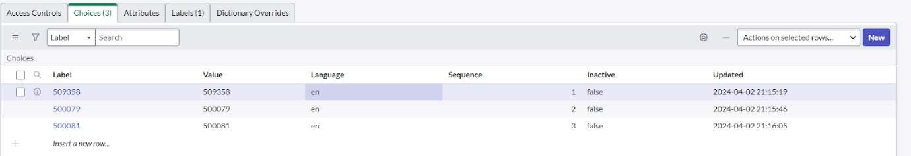

* + Create choice for Purpose of Join as:

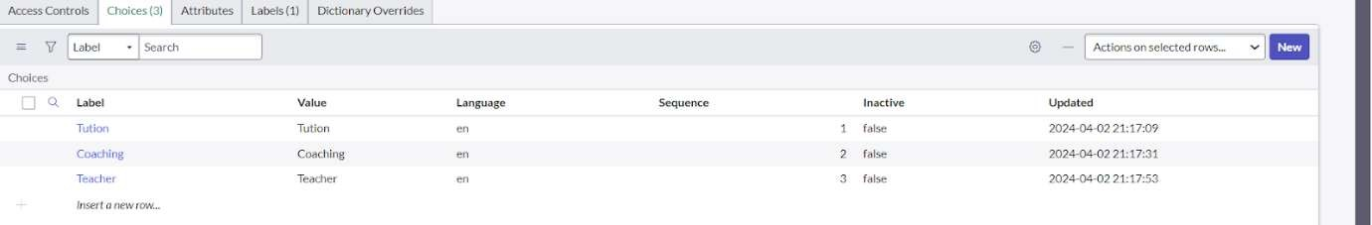

* + Create choice for School as:

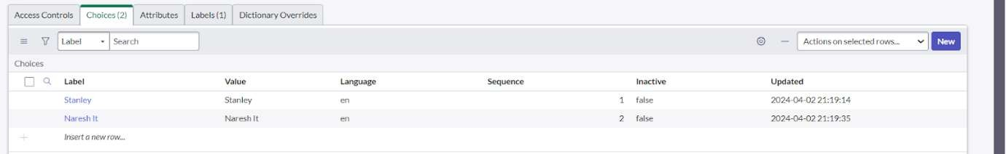

* + Create choice for School Area as:

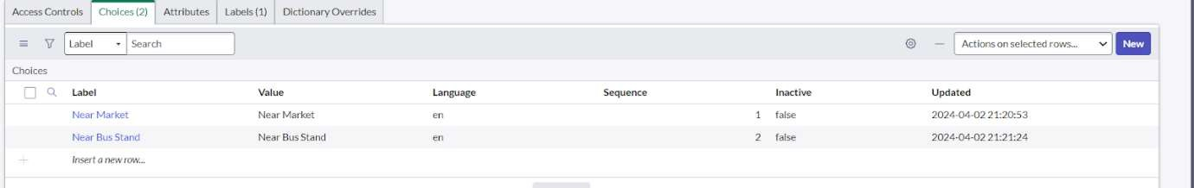

# Creating Student Progress Table

* + Create a Student Progress Table with Columns given.
  + Select Add module to menu >> Salesforce.
  + Create Fields as shown:

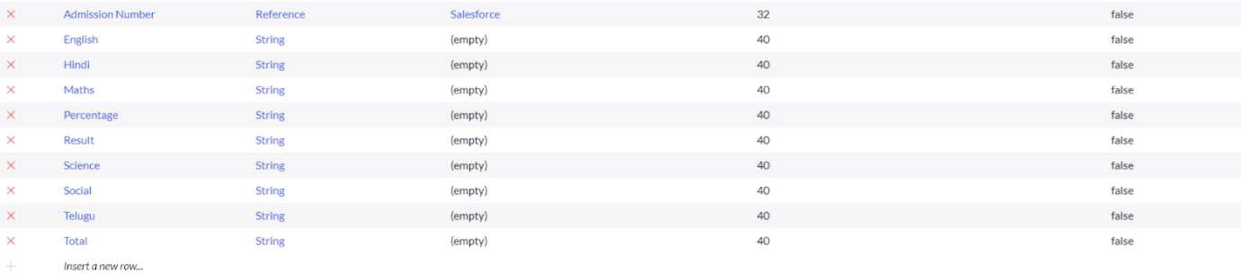

# Configuring Table form for Student Progress Table

* + In the Student Progress Table Page , Click on Layout form .

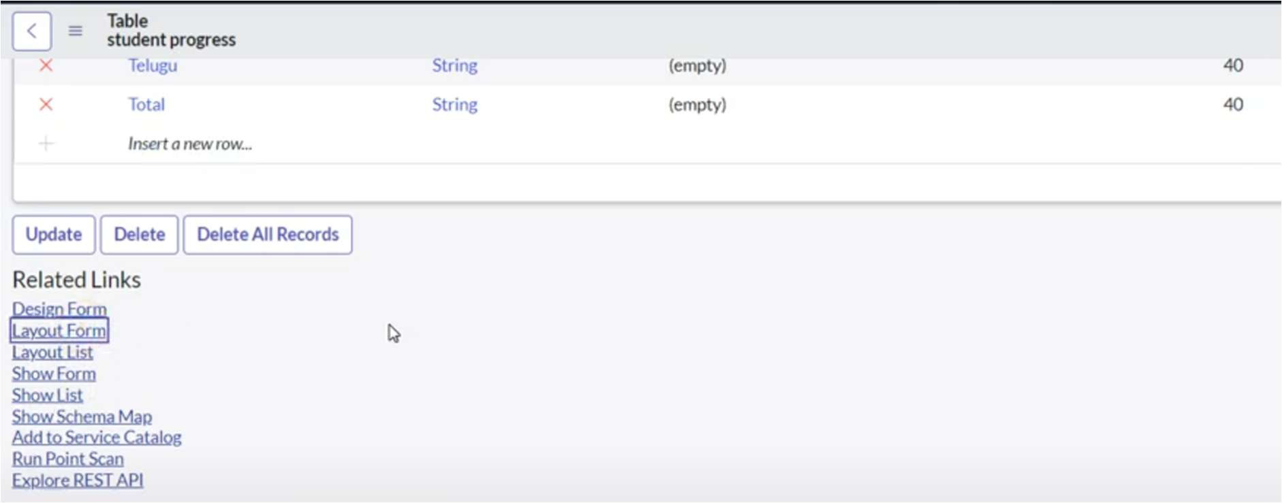

* + Click on Admission Number [+] .

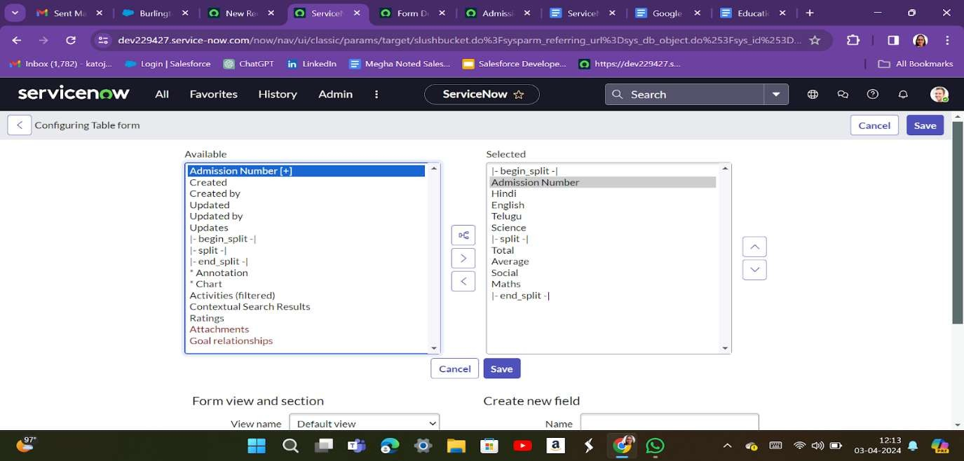

* + Select below Admission Number fields in Available side and send it to selected side as below >> save.

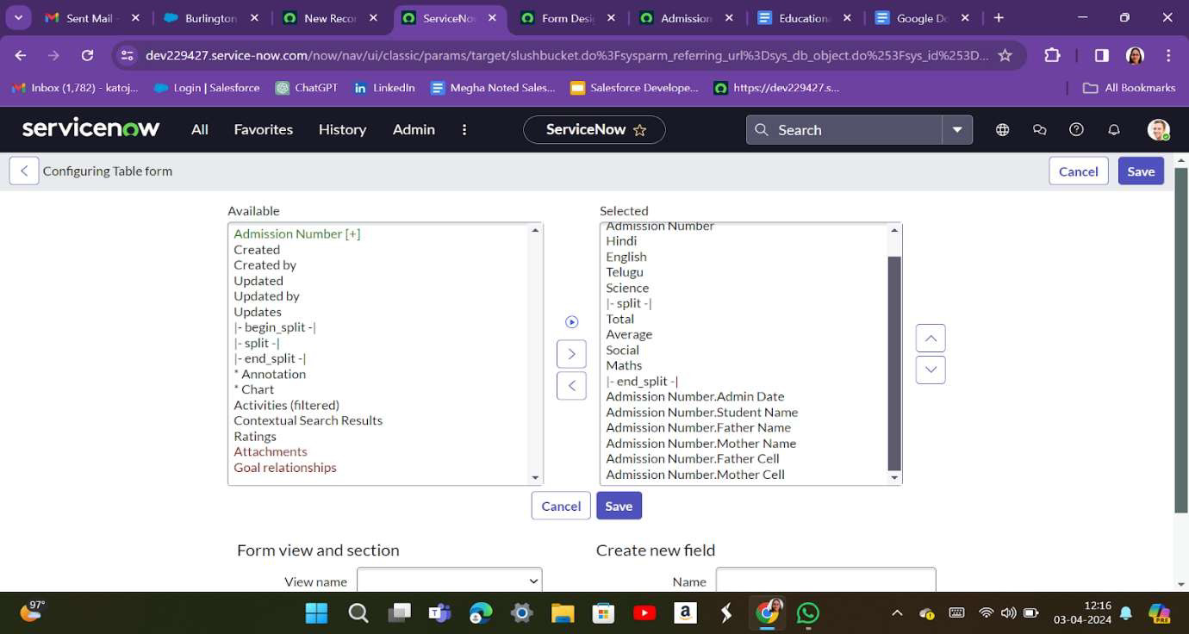

# Creating Form Design for Salesforce Table

1. All >> System Definition >> Tables .
2. In Label Search for Salesforce and open .

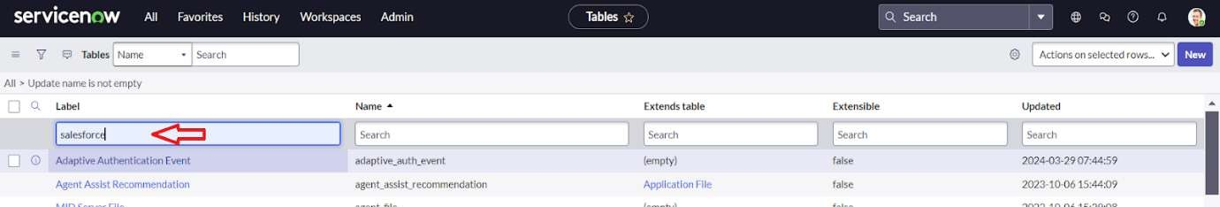

1. Right Click on top Toggle >> Configure >> Form Design.

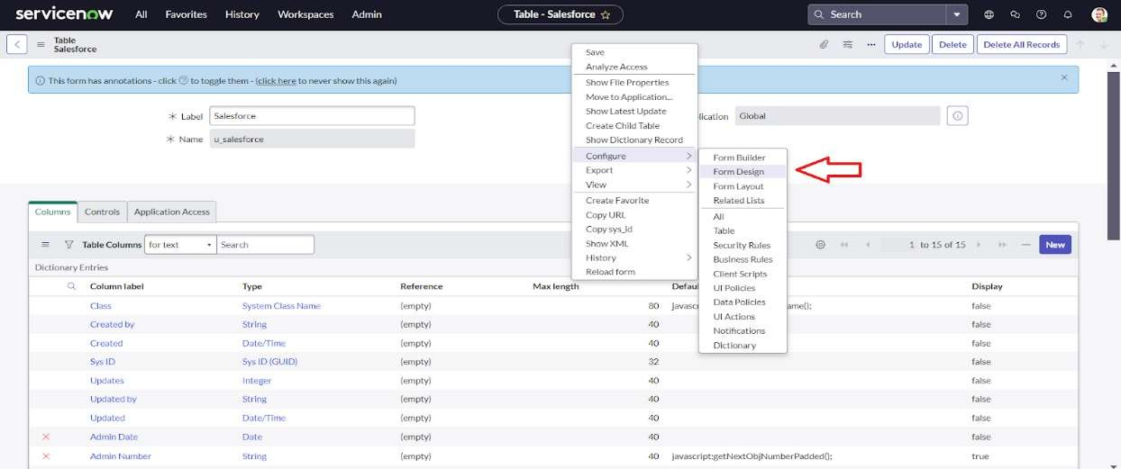

1. In drop down select Salesforce(u_salesforce).

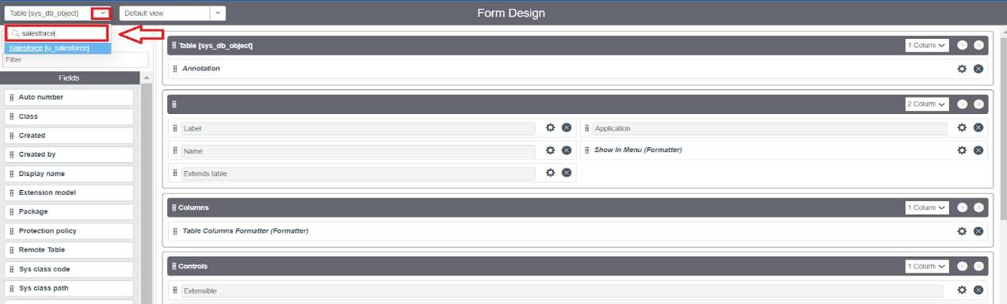

1. Drag and drop the fields to the left side as below.

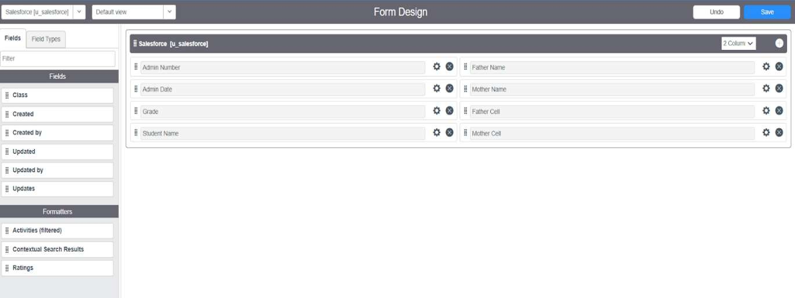

1. Save.

# Creating Form Design for Admission Table

Follow the same steps as Activity1, Configure the fields as below and Save.

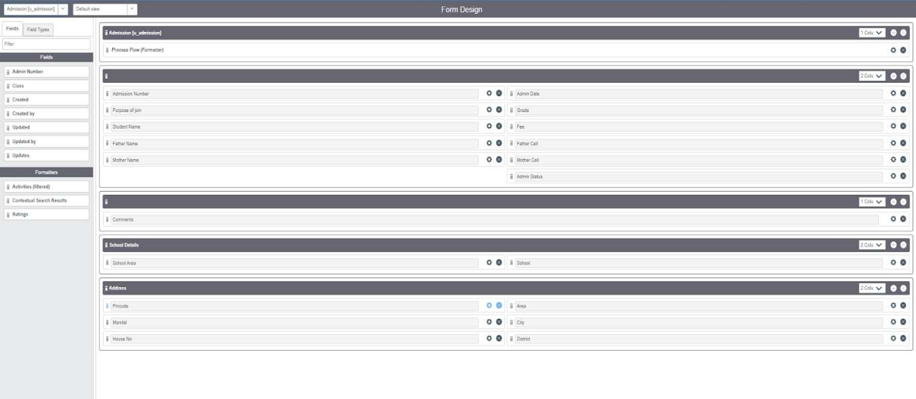

# Creating Form Design for Student progress Table

Follow the same steps as Activity1, Configure the fields as below and Save.

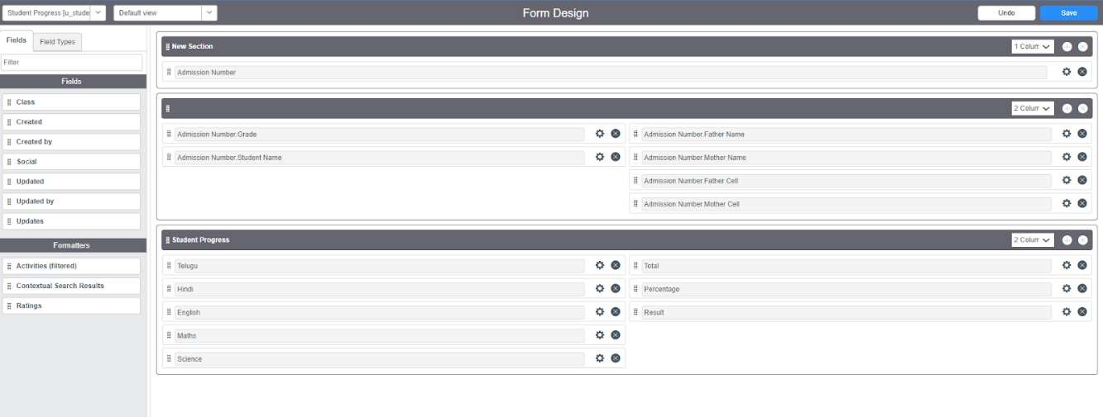

# Creating Number Maintenance for Admin Number

* + All >> Number Maintenance >> New

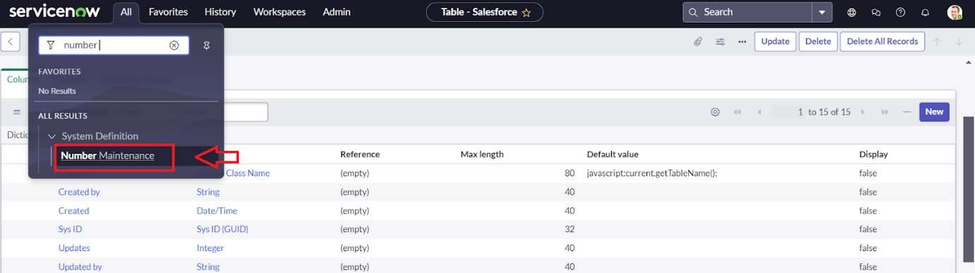

* + Fill the details >> Submit.

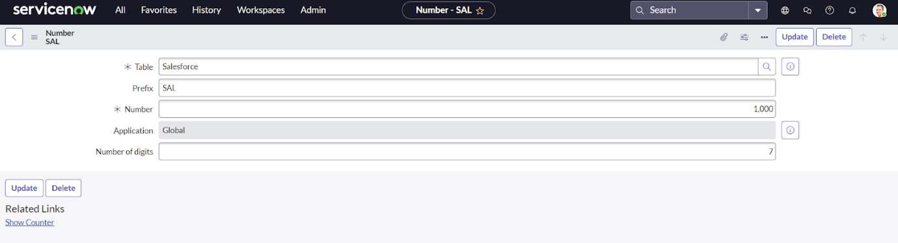

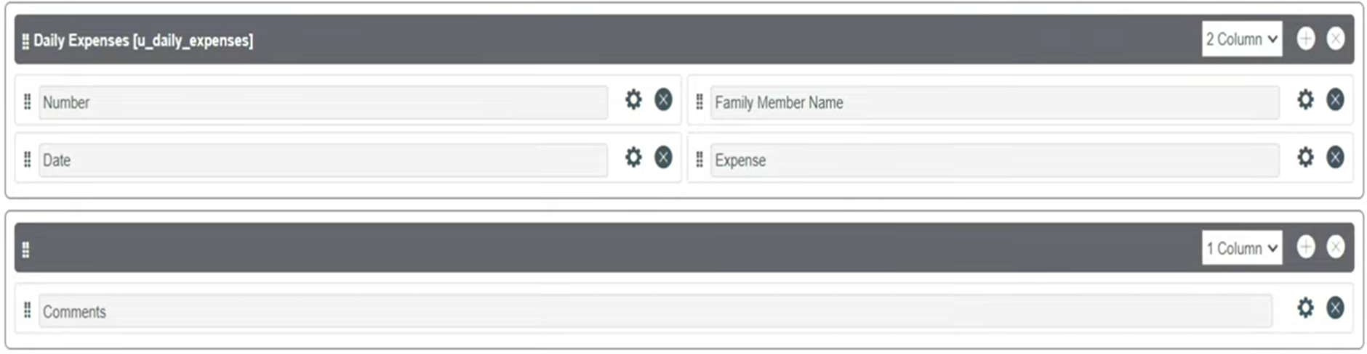

# Creating Process Flow for Admission Table

* + All >> Process Flow>> New.
  + Fill the Details as given Below

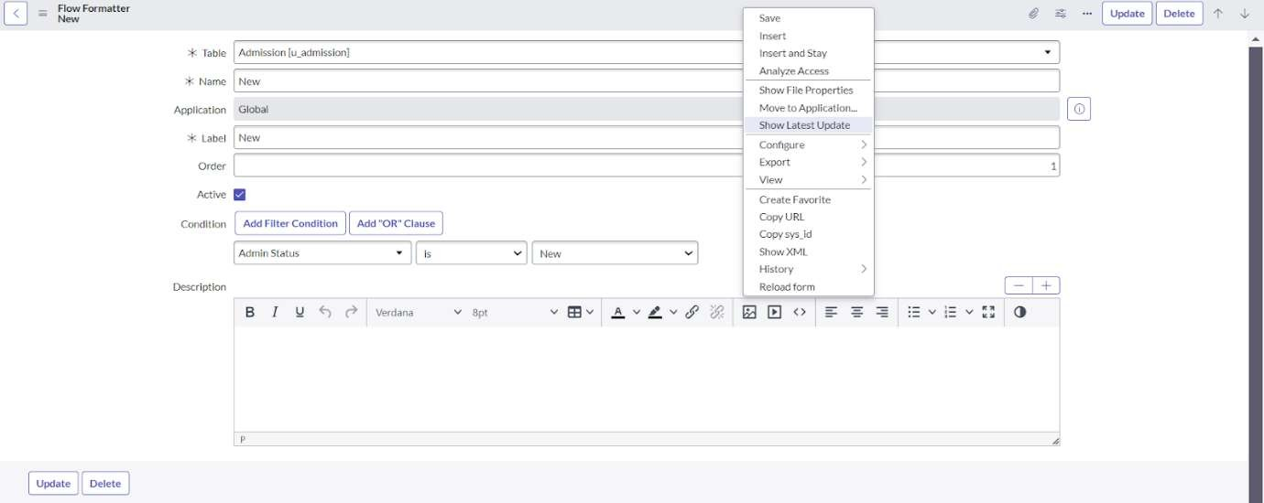

* + Right Click on toggle and click on the save .
  + Replace the Name and Label as below and click on Insert on stay.

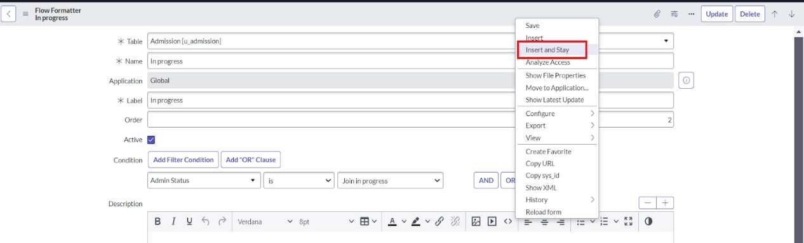

* + Replace the Name and Label in order and click on Insert on stay.

Joined >> Rejected >> Rejoined >> Closed >> Cancelled.

* + Order should be New >> InProgress >> Joined >> Rejected >> Rejoined >> Closed >> Cancelled.

# Creating “Auto populate” Client Scripts for Admission Table

1. All >> Client Scripts >> New.
2. Fill the Details as given.
3. 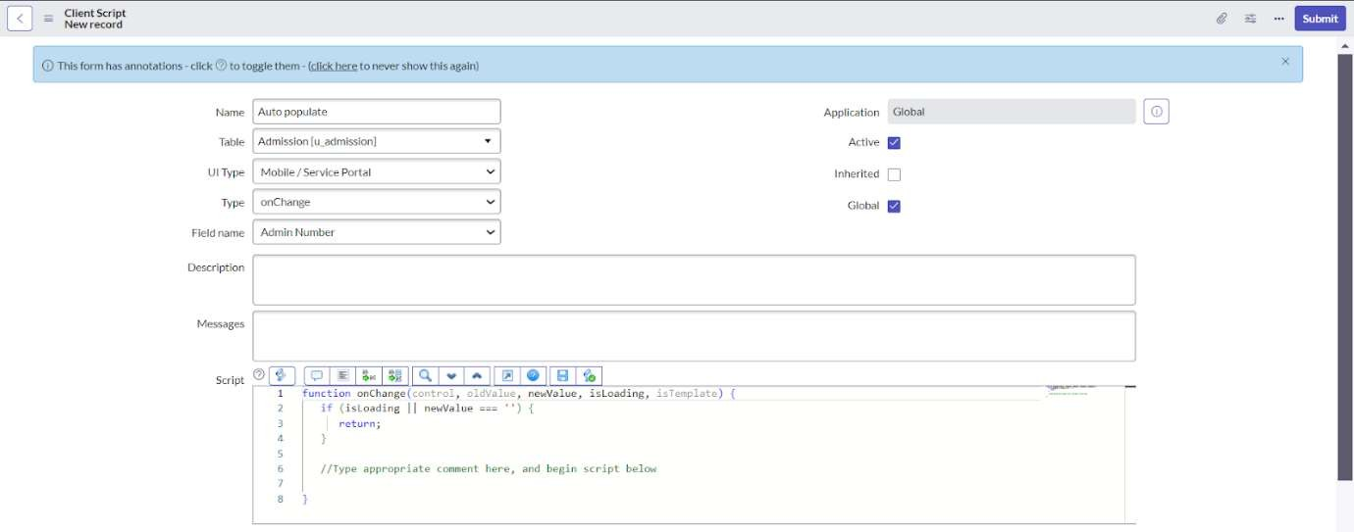
4. Write the Code as below, Enable Isolate script and Save.
5. function onChange(control, oldValue, newValue, isLoading, isTemplate) {
6. if (isLoading || newValue === '') {
7. return;

8. }

1. //Type appropriate comment here, and begin script below
2. var a = g_form.getReference('u_admission_number');
3. g_form.setValue('u_admin_date',a.u_admin_date);
4. g_form.setValue('u_grade',a.u_grade);
5. g_form.setValue('u_student_name',a.u_student_na me);
6. g_form.setValue('u_father_name',a.u_father_name

);

1. g_form.setValue('u_mother_name',a.u_mother_na me);
2. g_form.setValue('u_father_cell',a.u_father_cell);
3. g_form.setValue('u_mother_cell',a.u_mother_cell)

;

1. g_form.setDisabled('u_admin_date',a.u_admin_da te);
2. g_form.setDisabled('u_grade',a.u_grade);
3. g_form.setDisabled('u_student_name',a.u_student

_name);

1. g_form.setDisabled('u_father_name',a.u_father_na me);
2. g_form.setDisabled('u_mother_name',a.u_mother

_name);

1. g_form.setDisabled('u_father_cell',a.u_father_cell

);

1. g_form.setDisabled('u_mother_cell',a.u_mother_c ell);

25. }

1. Note: Make sure the Field names should be the same as you created .

# Creating “Pincode Update” Client Scripts for Admission Table

* + Fill the Details as given.

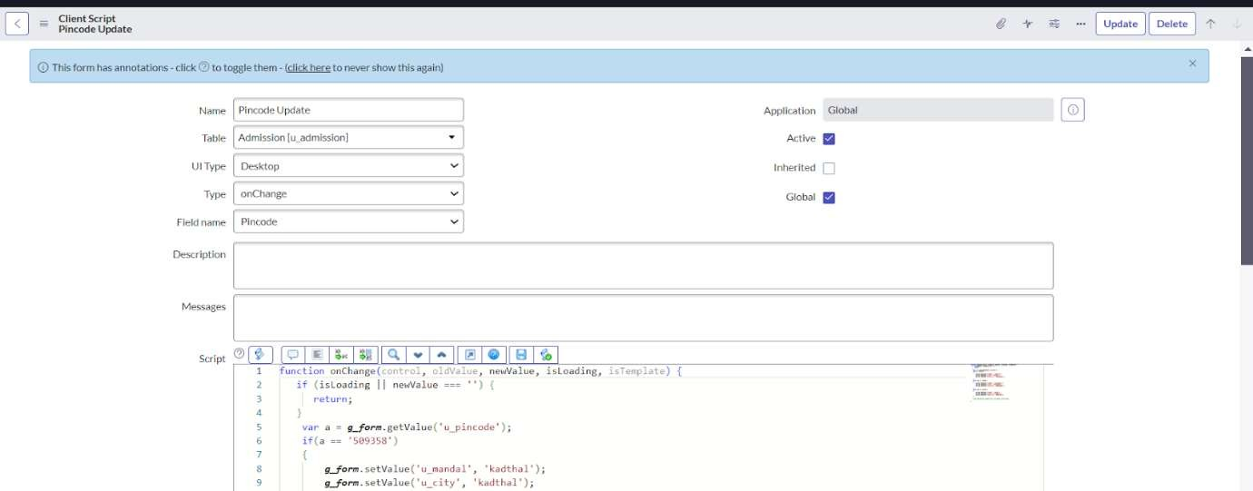

* + Write the Code as below, Enable Isolate script and Save.

function onChange(control, oldValue, newValue, isLoading, isTemplate) {

if (isLoading || newValue === '') { return;

}

var a = g_form.getValue('u_pincode'); if(a == '509358')

{

g_form.setValue('u_mandal', 'kadthal'); g_form.setValue('u_city', 'kadthal'); g_form.setValue('u_district', 'RangaReddy');

}

else if(a == '500081')

{

g_form.setValue('u_mandal', 'karmanghat'); g_form.setValue('u_city', 'karmanghat'); g_form.setValue('u_district', 'RangaReddy');

}

else if(a == '500079')

{

g_form.setValue('u_mandal', 'Abids'); g_form.setValue('u_city', 'AsifNagar'); g_form.setValue('u_district', 'Hyderabad');

}

//Type appropriate comment here, and begin script below

}

# Creating “Disable Fields” Client Scripts for Student progress Table

* + Fill the Details as given.

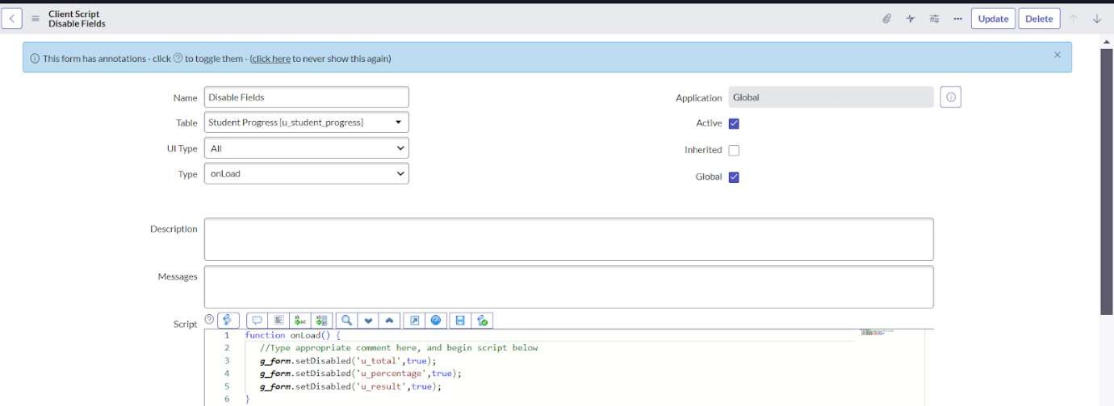

* + Write the Code as below, Enable Isolate script and Save.

function onLoad() {

//Type appropriate comment here, and begin script below g_form.setDisabled('u_total',true); g_form.setDisabled('u_percentage',true); g_form.setDisabled('u_result',true);

}

# Creating “Total Update” Client Scripts for Student progress Table

* + Fill the Details as given.

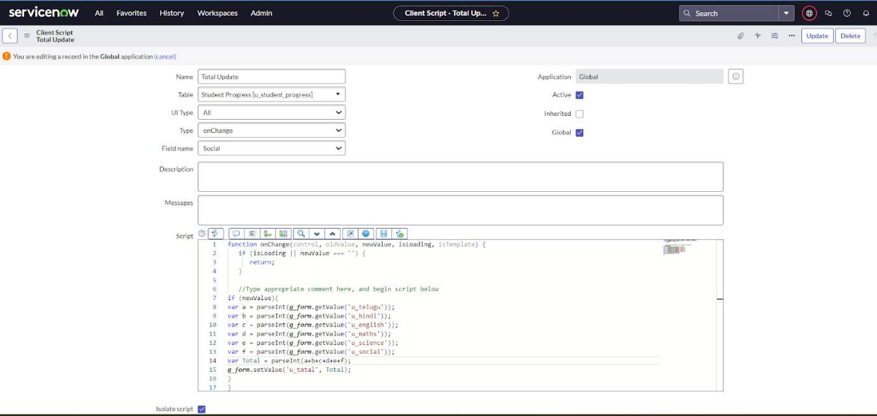

* + Write the Code as below, Enable Isolate script and Save.

function onChange(control, oldValue, newValue, isLoading, isTemplate) {

if (isLoading || newValue === '') { return;

}

//Type appropriate comment here, and begin script below if (newValue){

var a = parseInt(g_form.getValue('u_telugu')); var b = parseInt(g_form.getValue('u_hindi')); var c = parseInt(g_form.getValue('u_english')); var d = parseInt(g_form.getValue('u_maths')); var e = parseInt(g_form.getValue('u_science')); var f = parseInt(g_form.getValue('u_social')); var Total = parseInt(a+b+c+d+e+f); g_form.setValue('u_total', Total);

}

}

# Creating “Result” Client Scripts for Student progress Table

* + Fill the Details as given.

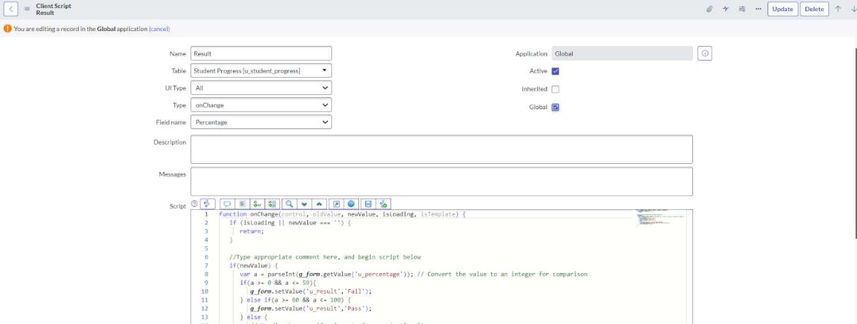

* + Write the Code as below, Enable Isolate script and Save.

function onChange(control, oldValue, newValue, isLoading, isTemplate) {

if (isLoading || newValue === '') { return;

}

//Type appropriate comment here, and begin script below if(newValue) {

var a = parseInt(g_form.getValue('u_percentage')); // Convert the value to an integer for comparison

if(a >= 0 && a <= 59){ g_form.setValue('u_result','Fail');

} else if(a >= 60 && a <= 100) {

g_form.setValue('u_result','Pass');

} else {

// Handle the case if a is out of range (optional) g_form.addErrorMessage('Percentage should be

between 0 and 100.'); g_form.clearValue('u_result');

}

}

}

# Creating “Percentage” Client Scripts for Student progress Table

* + Fill the Details as given.

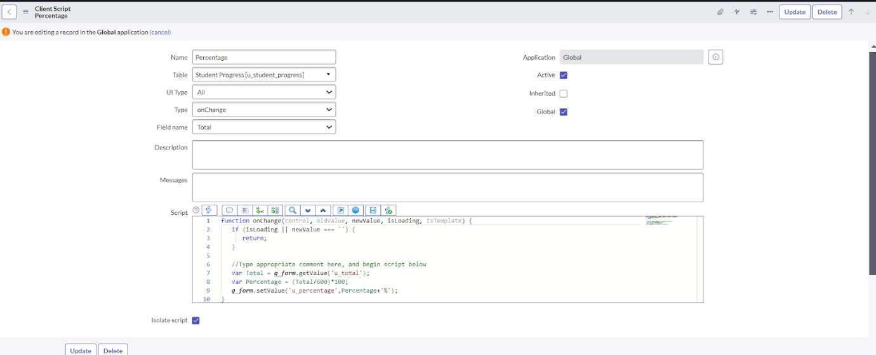

* + Write the Code as below, Enable Isolate script and Save.

function onChange (control, oldValue, newValue, isLoading, isTemplate) {

if (isLoading || newValue === '') { return;

}

//Type appropriate comment here, and begin script below var Total = g_form.getValue('u_total');

var Percentage = (Total/600)*100; g_form.setValue('u_percentage',Percentage+'%');

}

**Conclusion :** Whether for business or personal use, servicenow proves to be powerful tool for structured expense management.